James Noble
14 The Grove
Newington
NE23 9XR

August 2005
Membership number: 439240
Dear James

Our records show your date of birth as 1/10/1988, which means that you were 17 years old on or before 1 August this year. You are, therefore, no longer eligible for membership of the junior section of the library. However, I am pleased to inform you that you are now able to rejoin the library as an adult member.

We have produced a new library card for you and I would be grateful if you could call into the library sometime within the next few weeks to return your old junior card and to collect and sign your new adult membership card.

Yours sincerely

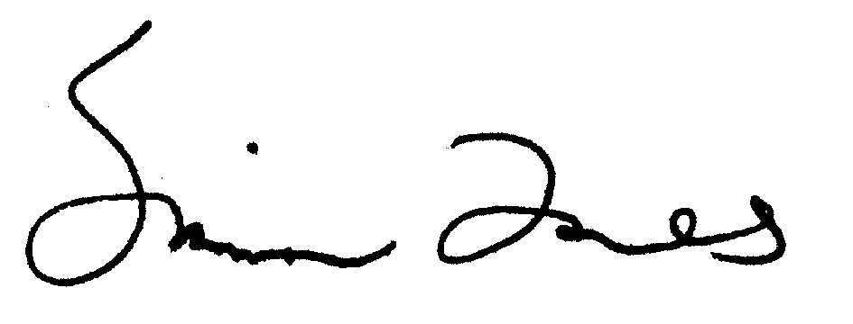

Simon Jones
(Head Librarian)

